Applied Databases

Topic 2 Exercise Sheet

NOTE: When you are doing these exercises, the point is more to understand the command to get the answer, rather than getting the answer.

To that end it would be better to write the SQL query/command you used under each question, so you’ll have it for future reference.

Description of the database.

The database consists of two tables, subject and teacher.

Subject Attribute Description Name

Name of Subject

Teacher Name of Teacher of Subject OnLeavingCert 0 (false) if the subject is NOT on the Leaving Cert Non 0 (true) if the subject IS on the Leaving Cert

Teacher Attribute Description Tid Teacher ID Name Name of Teacher Level Level the teacher is qualified to teach to: “J” means Junior Cert “L” means Leaving Cert Experience Years of Teaching Experience the Teacher has Dob Teacher’s date of birth

1. Get school.sql from Moodle and import it into MySQL.

2. What is the maximum length of data that can be inserted into the Name attribute of the subject table? – Describe subject; max length 15

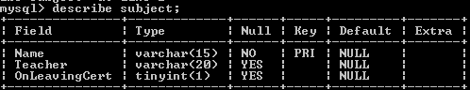

3. What is the Primary Key of the teacher table? Describe teacher;

Primary key is tid

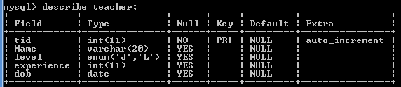

4. What is the Primary Key of the subject table? Describe subject; Primary key is Name

5. Show all data contained in the subject table. Select \* from subject;

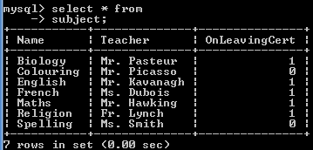

6. Show all names of all subjects that are on the leaving cert. Select \* from subject where OnLeavingCert = 1

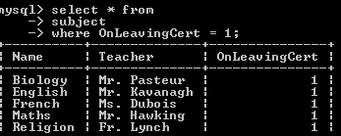

7. Show all name and experience of all teachers who are qualified to teach to Leaving Cert. Select name, experience from teacher where (level = “L”)

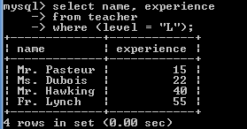

8. Show all details of all subjects who are taught by teachers whose title is not “Mr.”

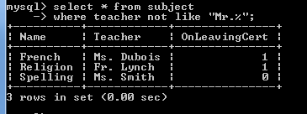

9. Show all details of all teachers who were born in January, February or March, and who can teach as far as Junior Cert only.

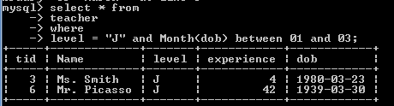

10. Show all unique month names that teachers were born in.

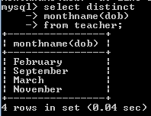

11. Show all details of all teachers, sorted by first by experience, then level.

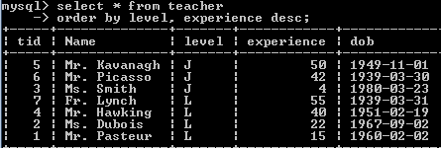

12. Show all details of all subjects whose 3rd or 4th letter is “l”. Sort them by name.

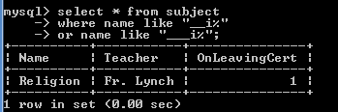

13. Show the name of all teachers who have 10, 15, 20, 25, 30, 35, 40, 45, 50, 55 or 60 years experience. Sort from youngest to oldest.

